7.2.1 Editors - 3D View - Header - Object menu
Detailed Table of content 3
Object menu 10
Transform 10
To Sphere 10
Shear 11
Bend 12
Push/Pull 12
Move Texture Space 13
Scale Texture Space 14
Align to Transform Orientation 15
Randomize Transform 16
Align Objects 16
Set Origin 17
Geometry to Origin 17
Origin to Geometry 17
Origin to 3D cursor 17
Origin to Center of Mass(Surface) 17
Origin to Center of Mass(Volume) 17
Mirror 18
Interactive Mirror 18
X Y Z Global 18
X Y Z Local 18
Clear 19
Clear 19
Apply 20
Apply 20
Visual Transform 21
Make Instances Real 21
Snap 21
Selection to Cursor 21
Selection to Cursor(Keep Offset) 21
Selection to Active 22
Selection to Grid 22
Cursor to Selected 22
Cursor to World Origin 22
Cursor to Active 22
Cursor to Grid 22
From Duplicate ... to Paste 22
Duplicate Objects 22
Duplicate Linked 23
Join 25
Delete 25
Delete Global 25
Copy 26
Paste 26
Parent 26
Object 26
Object ( Keep Transform) 26
Armature Deform 27
With empty Groups 27
With Envelope Weights 27
With automatic Weights 27
Bone 27
Bone Relative 27
Curve Deform 27
Follow Path 28
Path Constraint 28
Lattice Deform 29
Vertex 29
Vertex (Triangle) 30
Last Operator Make Parent 30
Keep Transform 30
Object (without inverse) 30
Clear Parent 30
Clear and Keep Transformation 30
Clear Parent Inverse 31
Collection 31
Move to Collection 31
Link to Collection 31
Create New Collection 32
Remove From Collection 32
Remove From all Unlinked Collections 32
Add selected To Active Collection 32
Remove Selected From Active Collection 32
Relations 32
Make Proxy 32
Make Instance Face 33
Make Local 34
Make Single User 34
Transfer Mesh Data 34
Transfer Mesh Data Layout 36
Constraints 37
Track 38
Damped Track Constraint 38
Track to Constraint 38
Lock Track Constraint 39
Make Links 39
Object to Scene 40
Object Data, Materials .. etc 40
Transfer UV Map 40
Shade Smooth and Shade Flat 40
Animation 41
Insert Keyframe 41
Delete Keyframe 41
Clear Keyframes 41
Bake Action 41
Rigid Body 42
Add Active 42
Add Passive 43
Remove 43
Change shape 43
Calculate Mass 43
Quick Effects 43
Quick Fur 44
Quick Explode 44
Quick Smoke 44
Quick Fluid 44
Subdivide 45
Last Operator Subdivision Set 45
Convert to 45
Curve from Mesh/Text 45
Mesh from Curve/Meta/Surf/Text 45
Grease Pencil from Curve 45
Show/Hide 46
Show Hidden 46
Hide Selected 46
Hide Unselected 46
Object specific menu items 46
Curve and Text 46
Empty, Image and Force Fields 46
Camera 47
Light 47

Detailed Table of content

Detailed table of content
Detailed Table of content 3
Object menu 10
Transform 10
To Sphere 10
Usage 10
Last Operator Add Ico Sphere Panel 10
Factor 10
Proportional editing 10
Proportional Falloff 11
Proportional Size 11
Connected 11
Projected(2D) 11
Shear 11
Last Operator Shear 11
Offset 11
Shear Axis 11
Axis 11
Axis Ortho 11
Orientation 11
Proportional editing 12
Proportional Falloff 12
Proportional Size 12
Connected 12
Projected(2D) 12
Bend 12
Push/Pull 12
Last Operator Push/Pull 12
Factor 12
Proportional editing 12
Proportional Falloff 12
Proportional Size 13
Connected 13
Projected(2D) 13
Move Texture Space 13
Last Operator Move 13
Move 13
Orientation 13
Proportional editing 13
Proportional Falloff 14
Proportional Size 14
Connected 14
Projected(2D) 14
Scale Texture Space 14
Last Operator Resize 14
Move 14
Orientation 14
Proportional editing 14
Proportional Falloff 14
Proportional Size 14
Connected 14
Projected(2D) 14
Align to Transform Orientation 15
Last Operator Transform 15
Values 15
Axis 15
Orientation 15
Proportional editing 15
Proportional Falloff 15
Proportional Size 15
Connected 15
Projected(2D) 15
Randomize Transform 16
Last Operator Randomize Transform 16
Random Seed 16
Transform Delta 16
Randomize Location checkbox 16
Location edit boxes 16
Randomize Rotation checkbox 16
Rotation edit boxes 16
Randomize Scale checkbox 16
Scale Even 16
Scale edit boxes 16
Align Objects 16
Last Operator Align Objects 17
High Quality 17
Align Mode 17
Relative To 17
Align 17
Set Origin 17
Geometry to Origin 17
Origin to Geometry 17
Origin to 3D cursor 17
Origin to Center of Mass(Surface) 17
Origin to Center of Mass(Volume) 17
Last Operator Set Origin 17
Type 17
Center 18
Mirror 18
Interactive Mirror 18
Usage: 18
X Y Z Global 18
X Y Z Local 18
Last Operator Mirror 18
Orientation 18
Proportional editing 18
Proportional Falloff 18
Proportional Size 18
Connected 18
Projected(2D) 18
Clear 19
Clear 19
Location 19
Last Operator Clear Location 19
Clear Delta 19
Rotation 19
Last Operator Clear Rotation 19
Clear Delta 19
Scale 19
Last Operator Clear Scale 19
Clear Delta 19
Origin 19
Apply 20
Apply 20
Location, Rotation, Scale, All Transforms and Rotation&Scale 20
Last Operator Apply Object Transform. 20
Location 20
Rotation 20
Scale 20
Apply Properties 20
Location, Rotation, Scale and All Transforms to Deltas 20
Last Operator Transforms to Deltas 21
Mode 21
Reset Values 21
Animated Transform to Deltas 21
Visual Transform 21
Make Instances Real 21
Last Operator Make Instances Real 21
Parent 21
Keep Hierarchy 21
Snap 21
Selection to Cursor 21
Selection to Cursor(Keep Offset) 21
Last operator Snap Selection to Cursor 22
Offset 22
Selection to Active 22
Selection to Grid 22
Cursor to Selected 22
Cursor to World Origin 22
Cursor to Active 22
Cursor to Grid 22
From Duplicate ... to Paste 22
Duplicate Objects 22
Last Operator Duplicate 23
Duplicate Objects 23
Linked 23
Move X , Y , Z 23
Orientation 23
Proportional editing 23
Proportional Falloff 23
Proportional Size 23
Connected 23
Projected(2D) 23
Duplicate Linked 23
Last Operator Duplicate Linked 24
Duplicate Objects 24
Linked 24
Move X, Y, Z 25
Orientation 25
Proportional editing 25
Proportional Falloff 25
Proportional Size 25
Connected 25
Projected(2D) 25
Join 25
Delete 25
Delete Global 25
Copy 26
Paste 26
Last Operator Paste Selection from Buffer 26
Select 26
Active Collection 26
Parent 26
Object 26
Object ( Keep Transform) 26
Armature Deform 27
With empty Groups 27
With Envelope Weights 27
With automatic Weights 27
Bone 27
Bone Relative 27
Curve Deform 27
Follow Path 28
Path Constraint 28
Lattice Deform 29
Vertex 29
Vertex (Triangle) 30
Last Operator Make Parent 30
Type 30
Keep Transform 30
Object (without inverse) 30
Clear Parent 30
Clear and Keep Transformation 30
Clear Parent Inverse 31
Last Operator Clear Parent 31
Collection 31
Move to Collection 31
Last Operator Move to Collection 31
Name 31
Link to Collection 31
Last Operator Link to Collection 32
Name 32
Create New Collection 32
Last Operator Create New Collection 32
Name 32
Remove From Collection 32
Remove From all Unlinked Collections 32
Add selected To Active Collection 32
Remove Selected From Active Collection 32
Relations 32
Make Proxy 32
How to: 33
Make Instance Face 33
Usage: 33
Make Local 34
Make Single User 34
Transfer Mesh Data 34
Last Operator Transfer Mesh Data 34
Freeze Operator 34
Data Type 34
Create Data 34
Edge Mapping 34
Topology 34
Nearest Vertice 35
Nearest Edge 35
Nearest Face Edge 35
Projected Edge Interpolation 35
Auto Transform 35
Only Neighbor Geometry 35
Max Distance 35
Ray Radius 35
Mix Mode 35
Below Threshold 35
Above Threshold 35
Replace 35
Mix Factor 35
Transfer Mesh Data Layout 36
Last Operator Transfer Mesh Data Layout 36
Data Type 36
Exact Match 36
Source Layers Selection 36
Mygroup 36
Active Layer 36
All Layers 36
Destination Layers Matching 36
By Name 36
By Order 36
Active Layer 36
Constraints 37
Add Constraints ( With Targets) 37
Last Operator Add Constraints (with Target) 38
Type 38
Copy Constraints to Selected Objects 38
Clear Object Constraints 38
Track 38
Damped Track Constraint 38
Track to Constraint 38
Lock Track Constraint 39
Clear Track 39
Last Operator Clear track 39
Type 39
Clear Track - Keep Transformation 39
Last Operator Clear track 39
Type 39
Make Links 39
Object to Scene 40
Object Data, Materials .. etc 40
Last Operator Link Data 40
Type 40
Transfer UV Map 40
Shade Smooth and Shade Flat 40
Animation 41
Insert Keyframe 41
Insert Keyframe Menu 41
Delete Keyframe 41
Clear Keyframes 41
Bake Action 41
Last Operator Bake Action 42
Start Frame 42
End Frame 42
Frame Step 42
Only Selected Bones 42
Visual Keying 42
Clear Constraints 42
Clear Parents 42
Overwrite current Action 42
Bake Data 42
Rigid Body 42
Add Active 42
Add Passive 43
Last Operator Add Rigid bodies 43
Remove 43
Change shape 43
Last Operator Change Collision shape 43
Calculate Mass 43
Last Operator Calculate Mass 43
Material Preset 43
Density 43
Quick Effects 43
Quick Fur 44
Quick Explode 44
Quick Smoke 44
Quick Fluid 44
Subdivide 45
Last Operator Subdivision Set 45
Level 45
Relative 45
Convert to 45
Curve from Mesh/Text 45
Mesh from Curve/Meta/Surf/Text 45
Grease Pencil from Curve 45
Last Operator Convert to 45
Target 45
Keep Original 45
Show/Hide 46
Show Hidden 46
Hide Selected 46
Hide Unselected 46
Object specific menu items 46
Curve and Text 46
Extrude Size 46
Width Size 46
Empty, Image and Force Fields 46
Empty Draw Size 47
Camera 47
Camera Lens Angle 47
DOF Distance 47
Light 47
Energy 48
Radius 48
Spot Size 48
Spot Blend 48
Size X 48

Object menu

The object menu in Object mode provides you with tools to work at Object level.

It contains things like undo redo, copy and paste, delete and other general tools. But also some object specific tools, like the Convert to menu. Or Transform items, and many more.

There are lots of tools in this menu. So we will divide it into sub chapters.

Transform

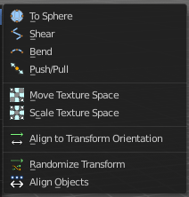
The transform sub menu contains functionality for some kind of transformations.

To Sphere
Shapes a selection of objects into the shape of a sphere. The calculation happens with the object origins.
In Object mode this tools requires to have more than one object selected.

Usage
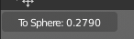
Select the objects, activate the tool, then drag the mouse in the 3D viewport. In the header you will read the current factor then. Which tells you how close you are towards the sphere shape.
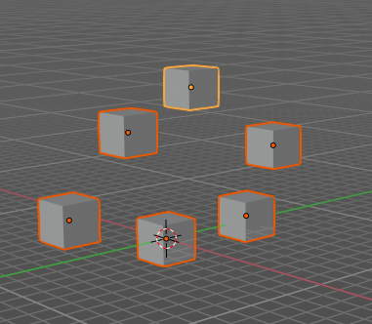
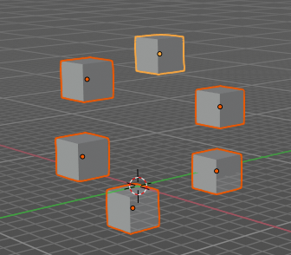

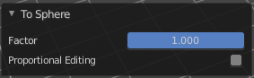
Last Operator Add Ico Sphere Panel

Factor
The factor to transform the selection into a shape form.

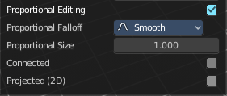
Proportional editing
Enables proportional editing. Activating proportional editing reveals further settings.

Proportional Falloff
Here you can adjust the falloff methods.

Proportional Size
Here you can see and adjust the falloff radius.

Connected
The proportional falloff gets calculated for connected parts only.

Projected(2D)
The proportional falloff gets calculated in the screen space. Depth doesn't play a role. When it's in the radius, then it gets calculated.

Shear
Shear shears the selection.
In Object mode this tools requires to have more than one object selected.

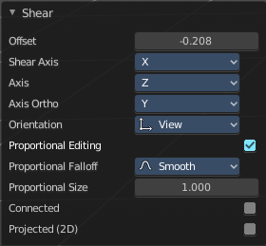
Last Operator Shear

Offset
Here you can adjust an offset.

Shear Axis
The shear tool works along a imaginary 2d plane. The shear axis controls if the itemas are sheared along the x or the y axes of this plane. This is the plane along which the transformation happens. You can shear along the x or the y axis of this plane.
To make things even more complicated, the orientation of this imaginary plane is defined by the Axis and Axis Ortho items below.

Axis
Defines one axis of the imaginary shear axis plane.

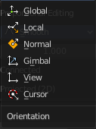
Axis Ortho
Defines the other axis of the imaginary shear axis plane.

Orientation
Here you can choose the orientation for the shear action.

Proportional editing
Enables proportional editing. Activating proportional editing reveals further settings.

Proportional Falloff
Here you can adjust the falloff methods.

Proportional Size
Here you can see and adjust the falloff radius.

Connected
The proportional falloff gets calculated for connected parts only.

Projected(2D)
The proportional falloff gets calculated in the screen space. Depth doesn't play a role. When it's in the radius, then it gets calculated.

Bend
Bends the selection.
In Object mode this tools requires to have more than one object selected.

Push/Pull
It pushes or pulls the object positions relative to the center of the selection.
In Object mode this tool requires to have more than one object selected.

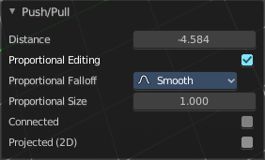
Last Operator Push/Pull

Factor
Here you can adjust the strength of influence of the tool.

Proportional editing
Enables proportional editing. Activating proportional editing reveals further settings.

Proportional Falloff
Here you can adjust the falloff methods.

Proportional Size
Here you can see and adjust the falloff radius.

Connected
The proportional falloff gets calculated for connected parts only.

Projected(2D)
The proportional falloff gets calculated in the screen space. Depth doesn't play a role. When it's in the radius, then it gets calculated.

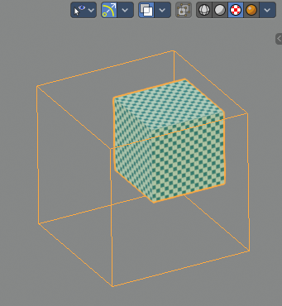
Move Texture Space
This tool relies at the move tool. With the difference that it moves the texture space instead of the object. It has also a very special use case, and just works with a material with a Texture Coordinate / Generated node. And requires to have the shading at Material or Rendered to see a result in the viewport.
The yellow cage represents the texture space. The actual UV mapping does not change.
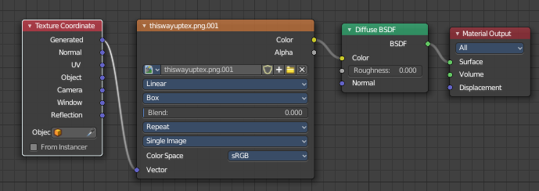

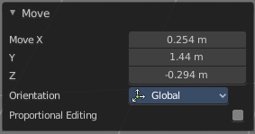
Last Operator Move

Move
Here you can adjust in which directions you want to transform.

Orientation
Here you can choose the orientation.

Proportional editing
Enables proportional editing. Activating proportional editing reveals further settings.

Proportional Falloff
Here you can adjust the falloff methods.

Proportional Size
Here you can see and adjust the falloff radius.

Connected
The proportional falloff gets calculated for connected parts only.

Projected(2D)
The proportional falloff gets calculated in the screen space. Depth doesn't play a role. When it's in the radius, then it gets calculated.

Scale Texture Space
Scale Texture space is similar to the Move texture Space. With the only difference that it scales the UV space instead of moving it.

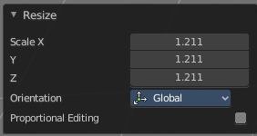
Last Operator Resize

Move
Here you can adjust in which directions you want to transform.

Orientation
Here you can choose the orientation.

Proportional editing
Enables proportional editing. Activating proportional editing reveals further settings.

Proportional Falloff
Here you can adjust the falloff methods.

Proportional Size
Here you can see and adjust the falloff radius.

Connected
The proportional falloff gets calculated for connected parts only.

Projected(2D)
The proportional falloff gets calculated in the screen space. Depth doesn't play a role. When it's in the radius, then it gets calculated.

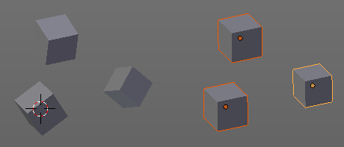
Align to Transform Orientation
Align to Transform Orientation rotates the selected objects so that their local orientation matches the active transform orientation in the Transform orientation panel or the Orientation selection in the Transform Operator panels.
For example when you have a few cubes that are rotated differently, then perform align to transform orientation with Global coordinates, then the cubes rotations gets set back to 0/0/0

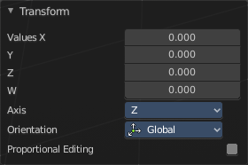
Last Operator Transform

Values
These values can't be editet. The tool aligns to zero, so the values turns to zero.

Axis
These values doesn't matter. Changing them does nothing.

Orientation
Here you can choose the orientation in which the transform should happen.

Proportional editing
Enables proportional editing. Activating proportional editing reveals further settings.

Proportional Falloff
Here you can adjust the falloff methods.

Proportional Size
Here you can see and adjust the falloff radius.

Connected
The proportional falloff gets calculated for connected parts only.

Projected(2D)
The proportional falloff gets calculated in the screen space. Depth doesn't play a role. When it's in the radius, then it gets calculated.

Randomize Transform
This tool allows to randomize position rotation and scale of selected objects. Each object gets threaten individually by a random value.
It starts with zeroed values. You need to adjust the values in the last operator.

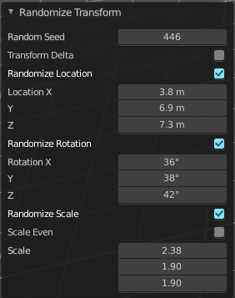
Last Operator Randomize Transform

Random Seed
Here you can adjust the random seed value.

Transform Delta
Randomize Delta transform values instead of the regular transform values.

Randomize Location checkbox
With this checkbox ticked the location of the selected objects gets randomiz

Location edit boxes
Here you can adjust the strength of the transform for the single axis.

Randomize Rotation checkbox
With this checkbox ticked the rotation of the selected objects gets randomiz

Rotation edit boxes
Here you can adjust the strength of the transform for the single axis.

Randomize Scale checkbox
With this checkbox ticked the scale of the selected objects gets randomized.

Scale Even
Use the same scale values for all axis.

Scale edit boxes
Here you can adjust the strength of the transform for the single axis.

Align Objects
Align Objects allows you to align the selected objects in various ways. You need to adjust the settings in the Last operator panel. The align operation happens in world coordinates.

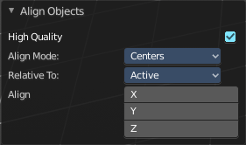
Last Operator Align Objects

High Quality
When ticked the calculation gets performed in a higher precision.

Align Mode
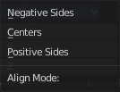
Align Mode is a drop-down box where you can choose between different align modes.

Relative To
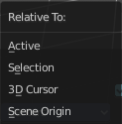
Relative to is a drop-down box. Here you adjust in what method the alignment happens.
Relative to the active object, to the center of selection, to the 3D cursor or to the scene origin.

Align
Here you can turn on or off the single axis for the align operation.

Set Origin

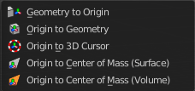
Set origin sets the origin of the selected objects to a chosen location.

Geometry to Origin
Sets the geometry to origin.

Origin to Geometry
Sets the origin to geometry.

Origin to 3D cursor
Sets the origin to the 3D cursor.

Origin to Center of Mass(Surface)
Sets the origin to the center of mass, calculating it from the center of the surface area.

Origin to Center of Mass(Volume)
Sets the origin to the center of mass, calculating from the center of the Volume. It must be manifold geometry with consistent normals.

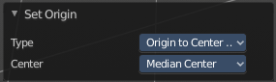
Last Operator Set Origin
The last operator is the same for all set origin methods.

Type
Here you can choose the method again.

Center
Use the median center or the bounds center for calculation.

Mirror
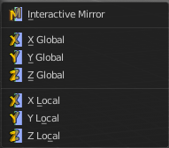
Mirrors the selection.

Interactive Mirror
Mirrors the selection.

Usage:
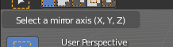
Activate the tool. In the header you will now see further instructions. Which is: type in the axis at which you want to mirror. Interactive mirroring starts in Global space. You can change the orientation in the last operator.

X Y Z Global
Mirrors along the global axis.

X Y Z Local
Mirrors along the object axis.

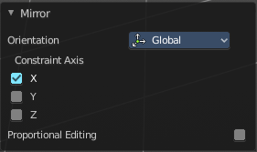
Last Operator Mirror

Orientation
Here you can choose the orientation in which the transform should happen.

Proportional editing
Enables proportional editing. Activating proportional editing reveals further settings.

Proportional Falloff
Here you can adjust the falloff methods.

Proportional Size
Here you can see and adjust the falloff radius.

Connected
The proportional falloff gets calculated for connected parts only.

Projected(2D)
The proportional falloff gets calculated in the screen space. Depth doesn't play a role. When it's in the radius, then it gets calculated.

Clear

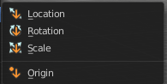
Clear
Clear Transform is a menu where you can clear the transform for location, rotation, scale and Origin. Clear means in this conjunction that the values gets reset.
When you have for example a cube at X 5, and clear the location, then the cube gets positioned at position X 0.

Location
Resets the location of the selected object(s).

Last Operator Clear Location

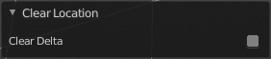
Clear Delta
With Clear Delta ticked it clears the delta transform instead of the transform.

Rotation
Resets the rotation of the selected object(s).

Last Operator Clear Rotation

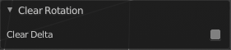
Clear Delta
With Clear Delta ticked it clears the delta transform instead of the transform.

Scale
Resets the scaling of the selected object(s).

Last Operator Clear Scale

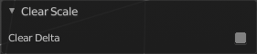
Clear Delta
With Clear Delta ticked it clears the delta transform instead of the transform.

Origin
Clear Origin requires to have a parent child relationship selected. It sets the child object to the position of the parent object.

Apply

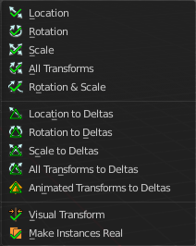
Apply
Apply is a menu where you can apply transforms in various combinations. For example, when you create a cube, then move it to let's say 3, then apply the location, then the origin gets set to 0. The position is "applied". Of special Interest is apply scale, since it resets the scale factor to 1.
Apply just works with single user objects. And it does not apply to pose position, animation curves or constraints. These tools should be used before rigging and animation.

Location, Rotation, Scale, All Transforms and Rotation&Scale
This applies the location, rotation and scale of the object.

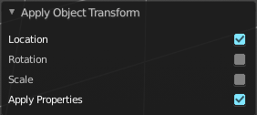
Last Operator Apply Object Transform.

Location
Applies the position, and resets origin to 0

Rotation
Applies the rotation.

Scale
Applies the Scale.

Apply Properties
Properties such as Curve Vertex Radius. Font Size and bone envelope gets applied.

Location, Rotation, Scale and All Transforms to Deltas
Transforms are absolute to the world coordinates. Delta Transforms are relative to the current transformation.
The delta transform values can be found in the Object properties, in the Delta Transform Panel.
Example use case:
Keyframe a object rotation from 0 to 90 degrees. Rotate the object by 45 degrees. When you play the animation it will still rotate from 0 to 90 degrees.
Now keyframe a delta rotation from 0 to 90 degrees and rotate the object by 45 degrees. When you playback the animation it will rotate from 45 to 135 degrees now. (a 90 degree difference from the current state)

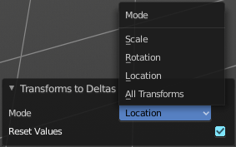
Last Operator Transforms to Deltas

Mode
Mode is a drop-down box where you can choose the transform mode again.

Reset Values
Clears the transform values after transferring to Deltas.

Animated Transform to Deltas
Converts the “normal” transformation animations to Delta transforms. This tool requires to have key frames at the object.

Visual Transform
Applies (set) the result of a constraint, and applies this back to the Object’s location, rotation and scale.

Make Instances Real
Make Instances real makes any duplicates attached to this Object real so that they can be edited.

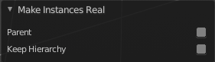
Last Operator Make Instances Real

Parent
Parent newly created objects to the original duplicator.

Keep Hierarchy
Keep Parent Child relationship.

Snap

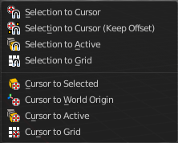
Selection to Cursor
Snaps the currently selected object(s) to the cursor location.

Selection to Cursor(Keep Offset)
Snaps the currently selected object(s) to the cursor location, but keeps the offset of the selected objects to each other. Means the center of the current selection goes to cursor position. Not every individual object.

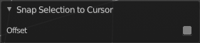
Last operator Snap Selection to Cursor

Offset
Keep the offset of the selected objects to each other.

Selection to Active
Snaps the currently selected object(s) to the active object.

Selection to Grid
Snaps the currently selected object(s) to the nearest grid point.

Cursor to Selected
Moves the cursor to the center of the selected object(s).

Cursor to World Origin
Moves the cursor to the world origin.

Cursor to Active
Moves the cursor to the center of the active object.

Cursor to Grid
Moves the cursor to the nearest grid point.

From Duplicate ... to Paste
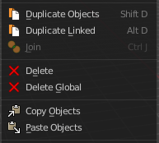

Duplicate Objects
Duplicates selected objects. The copy is completely independent. All containing data gets duplicated too. And you can edit the object instances completely independent. then.
You are automatically in grab mode, and so you can easily move the object out of position. Which is sometimes wanted, since you can position the duplicate then. But sometimes this is unwanted. A right click after releasing the mouse lets the object snap back into its creation position.
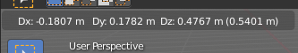
When you drag the duplicate around you will see the position values in the header.

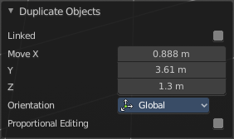
Last Operator Duplicate

Duplicate Objects

Linked
With this option ticked the duplication happens with linked data.

Move X , Y , Z
The Position of the duplicated object.

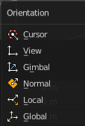
Orientation
Orientation is a drop-down box where you can choose the type of orientation for the duplicate action.

Proportional editing
Enables proportional editing. Activating proportional editing reveals further settings.

Proportional Falloff
Here you can adjust the falloff methods.

Proportional Size
Here you can see and adjust the falloff radius.

Connected
The proportional falloff gets calculated for connected parts only.

Projected(2D)
The proportional falloff gets calculated in the screen space. Depth doesn't play a role. When it's in the radius, then it gets calculated.

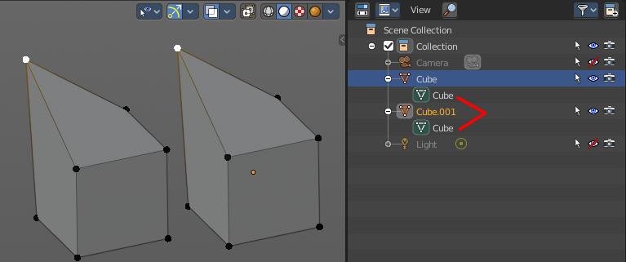
Duplicate Linked
Duplicates selected objects. The instance has its own transforms. But the duplicate shares some data with the first instance. This means when you for example edit the mesh of one of the instances, then the other instance gets modified too. As you can see this in the screenshot. Here you can also see that the mesh name is the same. The object name is different though.

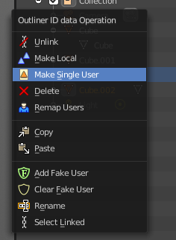
If you want to make changes to an object in the new linked duplicate independently of the original object, then you will have to manually make the object a “single-user” . This can be done for example in the Outliner, in the right click menu of the object. (Currently broken). Or in the Object menu. Here you can choose what attached data you want to make single user.
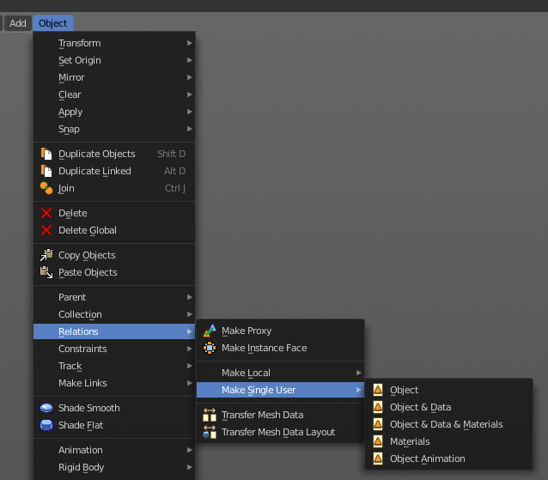

When you duplicate an object, then you are automatically in grab mode. And so you can easily move the object out of position. which is sometimes wanted, since you can position the duplicate then. But sometimes this is unwanted. A right click after releasing the mouse lets the object snap back into its creation position.
Duplicate linked instances the object data.
Explanation: Each Bforartists object type (mesh, lamp, curve, camera etc.) is composed from two parts: an Object and Object Data (sometimes abbreviated to ObData):
Object - Holds information about the position, rotation and size of a particular element.
Object Data - Holds everything else. For example. Meshes stores geometry, material lists, vertex groups, etc. . Cameras stores focal length, depth of field, sensor size, etc. .
Each object has a link to its associated object-data, and a single object-data, like a material, may be shared by many objects.

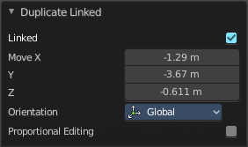
Last Operator Duplicate Linked

Duplicate Objects

Linked
With this option ticked the duplication happens with linked data.

Move X, Y, Z
The Position of the duplicated object

Orientation
Orientation is a drop-down box where you can choose the type of orientation for the duplicate action.

Proportional editing
Enables proportional editing. Activating proportional editing reveals further settings.

Proportional Falloff
Here you can adjust the falloff methods.

Proportional Size
Here you can see and adjust the falloff radius.

Connected
The proportional falloff gets calculated for connected parts only.

Projected(2D)
The proportional falloff gets calculated in the screen space. Depth doesn't play a role. When it's in the radius, then it gets calculated.

Join
Joins two independant objects together and makes them one object.

This works with mesh objects and with curve objects. What does not work is to try to join mesh objects with curve objects. They are of different type.

Delete
Delete deletes the selected object(s).

Delete Global
It can be that you have more than one scene open. Delete deletes the selected object(s) in all scenes.

Copy
Copies the selected object(s).

Paste
Pastes copied object(s).

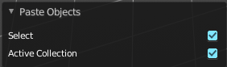
Last Operator Paste Selection from Buffer

Select
Select pasted object(s).

Active Collection
Put the pasted objects into the active collection.

Parent

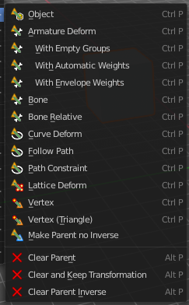
The parent menu provides you with all parenting methods at object level.

To use parenting you first have to select the source object, hold down shift, then select the target object so that both are selected. This also works in the outliner (here you can also simply hold down shift and drag the source object at the target object to make it a child). The source object becomes the child object then.

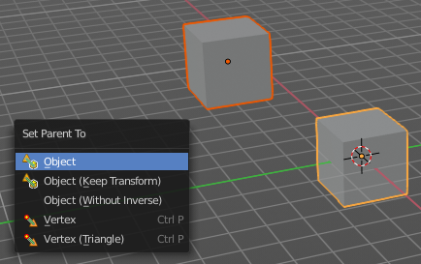
The methods are object type dependant. The armature methods requires to have a mesh and a armature. The path methods a curve. The available methods for the current selection can also be found out by pressing the hotkey ctrl P. This calls the parenting menu with just the available methods.

Object
Sets the parent to selected object.

Object ( Keep Transform)
Sets the parent to selected object, but applies all transform before the operation.

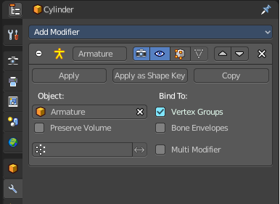
Armature parenting creates a armature modifier at the mesh.

Armature Deform
Sets the parent to selected Armature.

With empty Groups
Sets the parent to selected Armature, using empty groups.

With Envelope Weights
Sets the parent to selected Armature, using envelope weights

With automatic Weights
Sets the parent to selected Armature, with automatic weights.

Bone
Sets the parent absolute to selected Bone.

Bone Relative
Sets the parent relative to selected Bone.

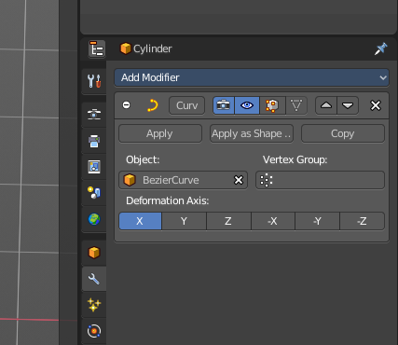
Curve Deform
Curve Deform allows you to deform a mesh by a curve shape. It adds a curve modifier at the mesh.

Usage:

Create a curve. Bend it in edit mode to your needs. Create a mesh. I have for demonstration purposes created a cylinder with several subdivisions.

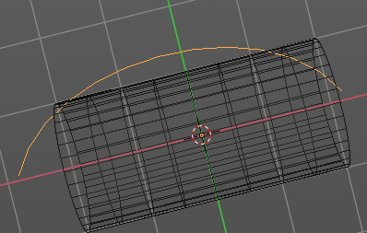

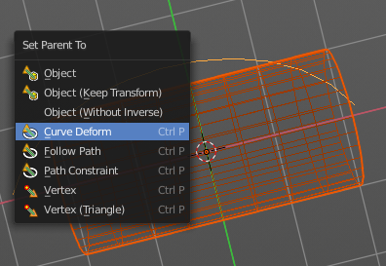
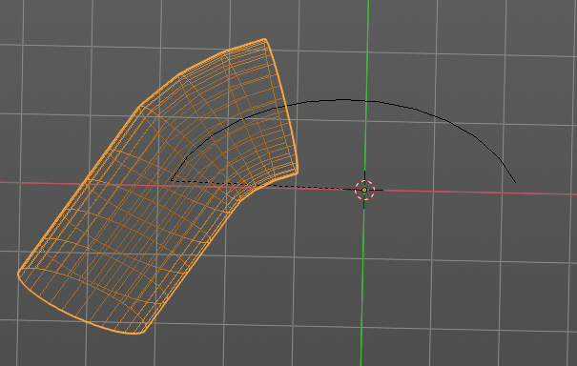

To demonstrate the only pitfall, by parenting the center of the object goes to the start point of the curve. So you better put the origin at the bottom of the cylinder before parenting.

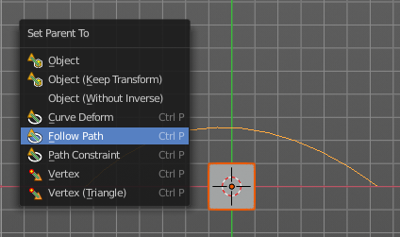
Follow Path
Attaches an object to a curve. The curve then gets used to animate the object position. Every vertice of the curve is one keyframe.
Create a curve, create an object, hold down shift and select the curve, make parent ...
Take care of the position and rotation of the object before parenting it to the curve. It influences how the object behaves.
There is a constraint with the same name and functionality. But parenting with follow path will not create such a constraint.

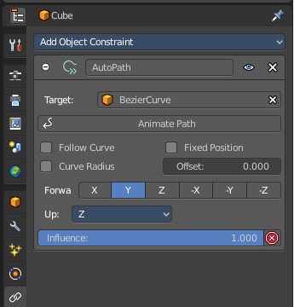
Path Constraint
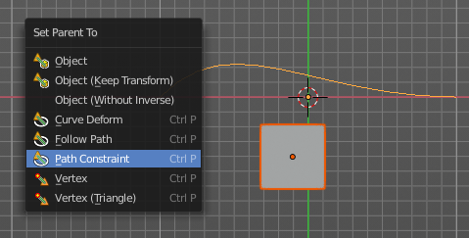
Path constraint adds a AutoPath constraint at the mesh object, which is most probably a wrong labeled path constraint. It is not documented by the Blender developers.

Create a curve, create an object, hold down shift and select the curve, make parent ...
Take care of the position and rotation of the object before parenting it to the curve. It influences how the object behaves.

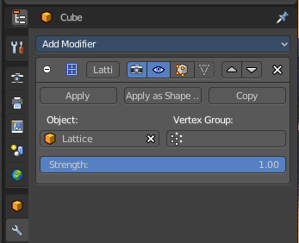
Lattice Deform
Parents a lattice object to the object.
You need a lattice object and a mesh object. Lattice deformations just works with mesh objects.
Create a lattice, create an object, hold down shift and select the lattice, make parent ...
Parent the mesh object to the lattice object with method Lattice Deform. A Lattice Deform constraint will be added at the mesh object.

Take care of the position and size of the lattice object. It influences how the deformation works.

Enter Edit Mode with the lattice object. Deform it. The mesh object will follow the deformation.
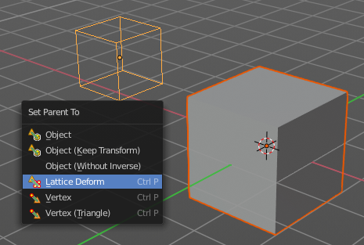
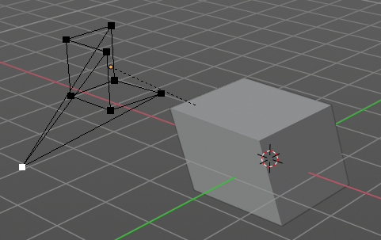

Vertex
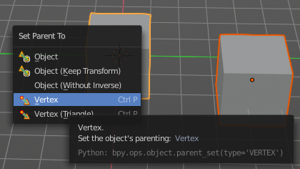
Vertex parents the current object to a vertex of the target object. The vertex will be chosen automatically, it's the
closest vertice of the parent object. When you want to assign the object to a specific vertice, then you have to do
the vertex parenting in Edit mode. You need to have an object type that has vertices. Mesh or curve.

Create a mesh or curve object, create an object, hold down shift and select the mesh object, make parent ...

Vertex (Triangle)
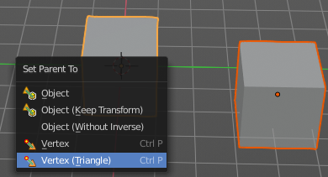
Vertex (Triangle) parents the current object to a face of the target object. The face will be chosen automatically.
It's the closest face of the parent object. When you want to assign the object to a specific face, then you have to
do the vertex parenting in Edit mode. You need to have an object type that has vertices. Mesh or curve.

Create a mesh or curve object, create an object, hold down shift and select the mesh object, make parent ...

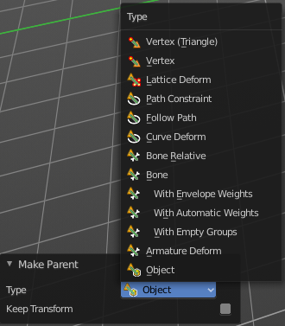
Last Operator Make Parent

Type
Here you can choose the make parent method again. This last operator counts for most of the parent actions.

Keep Transform
Apply transform before parenting.

Object (without inverse)
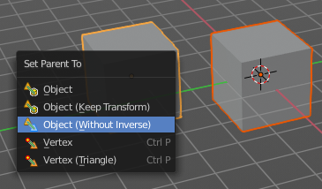
With normal parenting the child object keeps its world transformation.
Without inverse parenting the child object uses the coordinate system of the parent object. As one of the effects you will see that the child objects will jump to the origin of the parent object when parenting.

Clear Parent
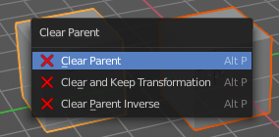
Clear Parent clears the parent relation completely, including involved modifiers.

Clear and Keep Transformation
Clear Parent clears the parent relation completely, including involved modifiers.
But keeps the current visual transformation.

Clear Parent Inverse
Clear Parent Inverse resets the transform corrections applied to the parenting relationship. It does not remove
the parenting itself.

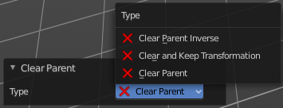
Last Operator Clear Parent
Here you can change the type of clearing.

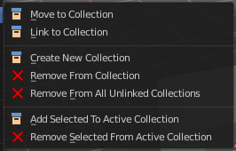
Collection

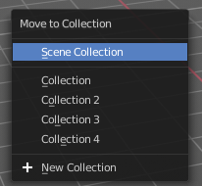
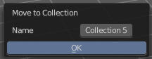
Move to Collection
Moves the selected object to a collection. The object is removed from the collection it was in.
By clicking at this menu item a popup will appear where you can choose the new collection. Here you can also create a new collection. Once done, the object will be moved to this new created collection.

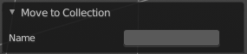
Last Operator Move to Collection

Name
Here you can set a name for your new collection. When you haven't created a new collection, then this name stays blank.

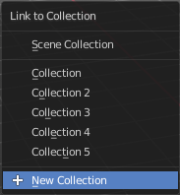
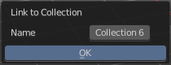
Link to Collection
Links the object to a collection. The object remains in the collection it was in.

By clicking at this menu item a popup will appear where you can choose the collection. Here you can also create a new collection. Once done, the object will be linked to this new created collection.

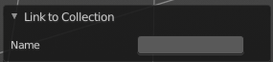
Last Operator Link to Collection

Name
Here you can set a name for your new collection. When you haven't created a new collection, then this name stays blank.

Create New Collection
Creates a new collection.

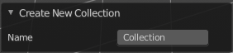
Last Operator Create New Collection

Name
Here you can set a name for your new collection.

Remove From Collection
Objects can be in more than one collection. Remove from collection removes the selected object from the current collection.
When the object is in no collection anymore, then it gets removed.

Remove From all Unlinked Collections
Objects can be in more than one collection. Remove from all unlinked collection removes the selected object from all unlinked collections.
When the object is in no collection anymore, then it gets removed.

Add selected To Active Collection
Objects can be in more than one collection. Adds the selected object to the active collection.

Remove Selected From Active Collection
Objects can be in more than one collection. Removes the selected object from the active collection.
When the object is in no collection anymore, then it gets removed.

Relations

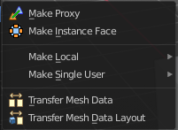
Make Proxy
Makes the active linked object into a local proxy, appending “_proxy” to its name.

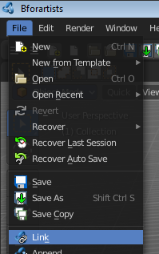
How to:

Create a library file. A file with a cube for example. I called it mylibrarycube for this example. Create a new scene. And link the mylibrarycube object from the library.

The linked cube will reside now in the middle of the viewport. You cannot move it, you cannot edit it.

Now go to Relations, Make Proxy, and make it a proxy object.

In the viewport the linked cube is not longer visible now. Just the created proxy object. And this proxy object is now editable, and you can move it around.
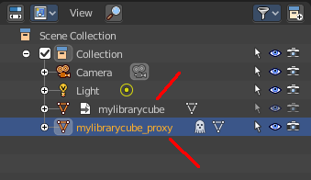
In the outliner the linked cube greys out, and a new instance called mylibrarycube_proxy is created. This is the editable instance. And the ghost icon tells you that it is a proxy object.

Possible changes are restricted. You can mainly edit and anmiate transformations of the proxy object and its constraints. Any changes remains local in the current scene, and does not affect the library object.

Make Instance Face
Make Instance Face, formerly Make Dupli Face, is a relict from the past, when there was no instancing or parenting feature available in Blender. When you turn an object into a Dupli Face object, then this object becomes an instancing container for this object. All objects in this container just exists once in ram when you duplicate it. No matter how often you duplicate it. This allows to plant whole forests without to run into a memory problem. Since the tree object just loads once into ram. And gets just drawn at different screen positions then.

Usage:
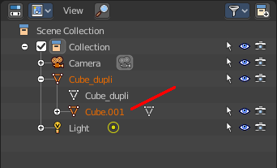
Create an object. Make Instance Face. The name will be extended by a _dupli term.

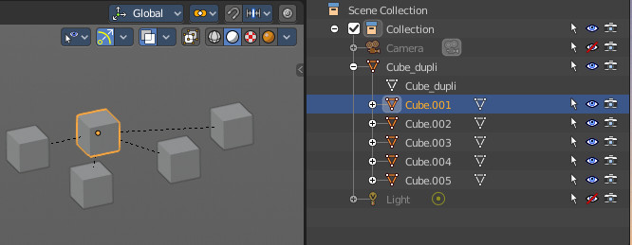
Now in the outliner go into the hierarchy of the dupli object. And duplicate the Cube.001 object inside of it. This is the parent object that you can duplicate. You will see that the duplicated copies will now be connected by a dotted line with the parent object.

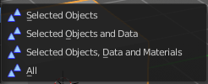
Make Local
You need to have a linked object for that. Make library linked datablocks local to this file. The link to the library object will be lost. And the object acts like you would have created it in the current scene.

There are four different methods available. With which you can also make the dependencies of the library object local. Materials for example.

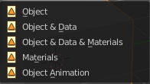
Make Single User
Make linked data local to each object. Additionally, it can also make single-user copies of its dependencies, like meshes, curves, materials, animations…

Transfer Mesh Data
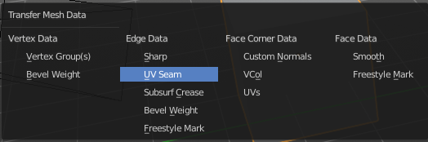
Transfers mesh data from active to selected object.

Select the object that you want to copy the data to, hold down shift, select the source object with the modifications at it. Choose Transfer Mesh Data. A popup with the available methods will appear. Choose what you want to do.

The caveat here is that the operator works in object mode. When you switch modes then the operator quits. And so you can't check if the uv seam transfer for example arrives as it should. This means that you sometimes end in trial and error with the last operator setting until you have your desired result.

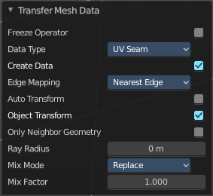
Last Operator Transfer Mesh Data

Freeze Operator
Prevent changes to settings to re-run the operator. This is useful if you are editing several settings at once with heavy geometry.

Data Type
The popup from above. Here you can again choose what you want to do.

Create Data
Add data layers on destination meshes if needed.

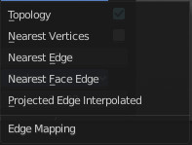
Edge Mapping
Edge mapping determines how edge data gets transfered.

Topology
This method expects to have the same number of items at both objects. Identical objects that gots deformed differently for example.

Nearest Vertice
Uses the nearest vertice of the source object for calculation.

Nearest Edge
Uses the nearest edge of the source object for calculation.

Nearest Face Edge
Uses the nearest edge of sources nearest face of the source object for calculation.

Projected Edge Interpolation
A sampling process that casts several rays from along the destination's edge for calculation.

Auto Transform
Automatically computes the transformation to get the best possible match between source and destination meshes.


Only Neighbor Geometry
Source elements must be closer than given distance from destination one. Turning this on reveals further settings.

Max Distance
Maximum allowed distance between source and destination element (for non-topology mappings).

Ray Radius
The width of rays.

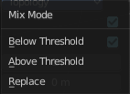
Mix Mode
How to affect destination elements with source values.

Below Threshold
Only replaces destination value if it is below given threshold Mix Factor. How that threshold is interpreted depends on data type, note that for boolean values this option fakes a logical OR.

Above Threshold
Only replaces destination value if it is above given threshold Mix Factor. How that threshold is interpreted depends on data type, note that for boolean values this option fakes a logical AND.

Replace
Replaces everything in destination (note that Mix Factor is still used).

Mix Factor
How much of the transferred data gets mixed into existing one (not supported by all data types).

Transfer Mesh Data Layout
Transfers the layout of data layer(s) from active to selected meshes.

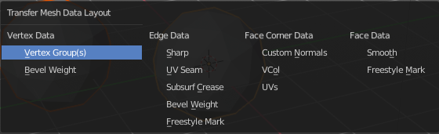
Select the object that you want to copy the data to, hold down shift, select the source object with the modifications at it. Choose Transfer Mesh Data Layout. A popup with the available methods will appear. Choose what you want to do.

The menu has basically the same menu items like Transfer Mesh Data. The difference is in what you can do in the last operator. It transfers the whole data layer.

Last Operator Transfer Mesh Data Layout

Data Type
Here you can again choose what you want to do.

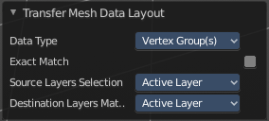
Exact Match
Also Delete some data layers from destination if necessary, so that it matches the source exactly.

Source Layers Selection
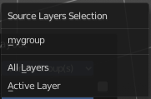
Which layers to transfer, in case of multi-layer types.

Mygroup
Mygroup is in this case a vertex group i have created for demonstration purposes.

Active Layer
Only transfer the active data layer.

All Layers
Transfer all data layers.

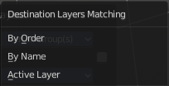
Destination Layers Matching
How to match source and destination layers.

By Name
Match target data layers to affect by name.

By Order
Match target data layers to affect by order (indices).

Active Layer
Only transfer the active data layer.

Constraints

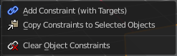
The constraints menu contains some functionality that could also be done in the constraints tab in the Properties editor. Those buttons provides a quicker access though.

Constraints provides you with various limitation methods connected to a target object. For example, you can limit the X position of an object to the X position of the target object. And when you move the target object, then the object will change its X position too.

Add Constraints ( With Targets)
Add Constraints ( With Targets) calls a menu where you can choose the constraints type. It's the same content than in the Constraints tab in the Properties editor.
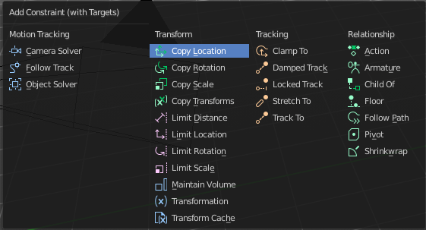
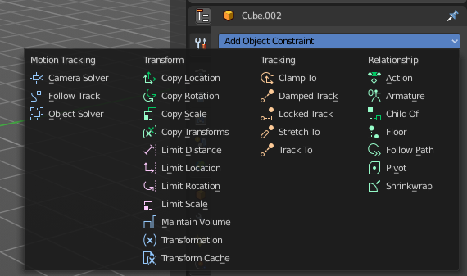

We will not explain every single constraint type here. Please have a look at the constraint types in the manual part for the Properties editor.
Usage:
Select the target object. Hold down Shift key. Now select the object where you want to add the constraints to. Both should be selected. Then choose the constraints type in the menu that you want to add.
As a result a constraints panel gets created in the Constraints tab in the Properties editor. Here you can tweak the settings then further if required. In our example we wanted to limit the X axis. So we added a Copy Location constraint, and unticked Y and Z axis. And when we move the cube around then the sphere will follow in X axis. But not in Y and Z.
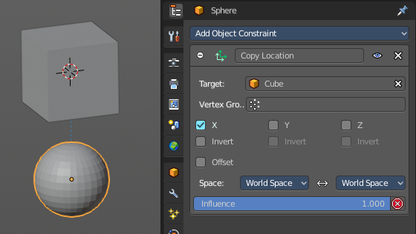
In the 3D view a dotted line indicates the relationship.

Last Operator Add Constraints (with Target)

Type
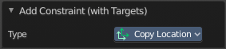
Type is a drop-down box where you can choose the constraints type again.

Copy Constraints to Selected Objects
Copy Constraints to Selected Objects copies a constraint from one object to another.
Usage:
Select the object where you want to copy the constraint to. Hold down Shift and select the object with the constraint. Both should be selected. Then click at Copy Constraints to Selected Objects. This copies the constraint to the object.

Clear Object Constraints
Removes all constraints from the object.

Track

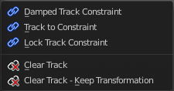
Track constraints are constraints. And adding them could also be done in the constraints tab in the Properties editor. Those buttons provides a quicker access though.

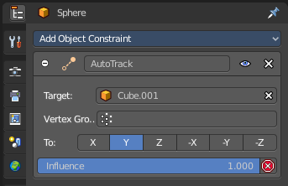
Damped Track Constraint
The Damped Track constraint constrains one local axis of the owner to always point towards Target. It is a Look At constraint.
Usage: select the source object, hold down shift, select the target object, add Damped Track Constraint.
The wrong constraint name called AutoTrack is a Blender bug.

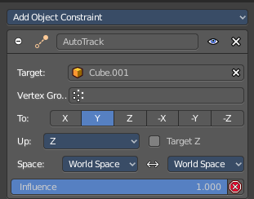
Track to Constraint
This constraint is similar to Damped Track constraints, but provides some more control.
Usage: select the source object, hold down shift, select the target object, add Damped Track Constraint. Constraint will be added at source object.
The wrong constraint name called AutoTrack is a Blender bug.

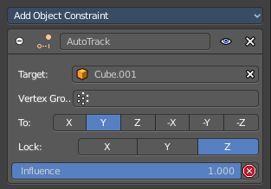
Lock Track Constraint
The Locked Track constraint is basically a Track To constraint. But with a locked axis. Means an axis that cannnot rotate. So the constraint can just follow in one defined axis.
The wrong constraint name called AutoTrack is a Blender bug.
Usage: select the source object, hold down shift, select the target object, add Track Constraint. Constraint will be added at source object.

Clear Track
You need to have a Track constraint applied. It removes the track constraint.

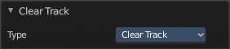
Last Operator Clear track

Type
Type is a drop-down box where you can choose between Clear Track and Clear Track Keep Transformation.

Clear Track - Keep Transformation
This menu item is just relevant when you have a Track constraint applied. Removes the track constraint. But keeps the current position.

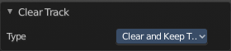
Last Operator Clear track

Type
Type is a drop-down box where you can choose between Clear Track and Clear Track Keep Transformation.

Make Links

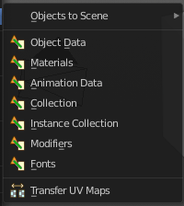
Links objects between scenes or data-blocks of the active object to all selected objects. In some case (i.e. Object Data, Modifier) the target objects must be of the same type than the active one or capable of receiving the data. If targets already have some data linked to them, it will be unlinked first.

Object to Scene
In Bforartists you can have more than one scene in the blend file. See Scenes tab. The make links menu allows you to link or copy objects between those scenes.

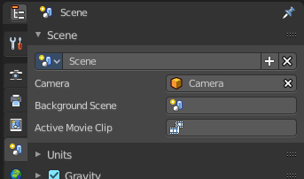
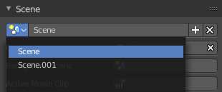

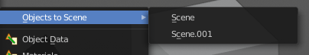
Object to Scene makes the selected object available in the chosen scene. This makes the object exist in two different scenes at once, including position and animation data.
When you want the object not to be shared across two scenes anymore, then you have to make it single user again, wich can be done in the relations menu.

Object Data, Materials .. etc
Link this specific data blocks between selected objects.
Select the source object, hold down shift, select the target objects. Perform the action.

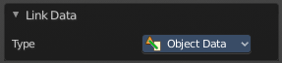
Last Operator Link Data

Type
Here you can choose the data type again that you want to transfer.

Transfer UV Map
Copies the UV map from one object to another. If the selected object doesn’t have any UV maps, then it is created. The Objects must be of type mesh and must have a matching topology.
Select the source object, hold down shift, select the target object. Perform Transfer UV Map.

Shade Smooth and Shade Flat
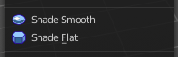
Sets the shading for the object to either smooth or flat. Flat means that every face of the object shows facettet, with a sharp edge. Smooth means that the edges are not longer to see.
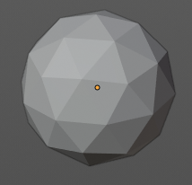
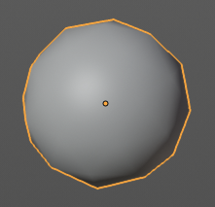

Animation
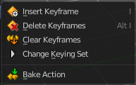

Insert Keyframe
Inserts a keyframe.
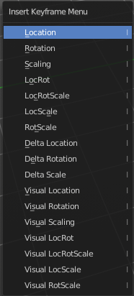
When your object does have a active keying set, then a click at the button inserts the keyframe directly. When a keying set is missing then you will see a Insert Keyframe menu where you can choose the keying method.

Insert Keyframe Menu
The keying set defines what kind of key frames gets recorded. When you start with an
animation, and your object does not have a keying set yet, then you will be prompted with a menu where you can choose the proper keying set. The Insert Keyframe menu.

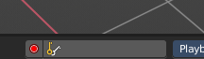
Note that this just adds a keying set to the current keyframe. And not to the whole object. That's why the keying set menu down right stays empty when you add a keyframe this way.

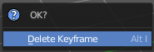
Delete Keyframe
Removes the current active keyframe for the selected object. You will get a confirmation dialogue.

Clear Keyframes
Clears all animation, and removes all key frames for the selected object.

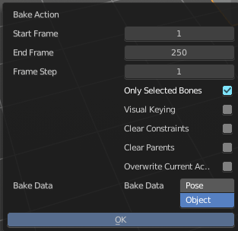
Bake Action
Bake Action bakes the object animation to a new action. Bake action calls a panel where you can adjust the settings for the new action.
The panel has the same settings than the last operator panel.

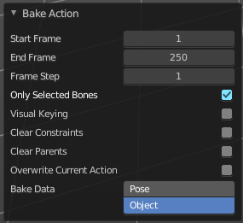
Last Operator Bake Action

Start Frame
Defines the start frame for baking.

End Frame
Defines the end frame for baking.

Frame Step
Defines the frame step for baking.

Only Selected Bones
Pose Baking only.

Visual Keying
Keyframe from the final transform.

Clear Constraints
Remove all constraints from keyed objects / bones, and do visual keying.

Clear Parents
Bake animation onto the object, then clear parents (objects only)

Overwrite current Action
Bake Action into current action instead of creating a new one.

Bake Data
Which data transformations to bake to. You have the choice between Pose and Object here.

Rigid Body
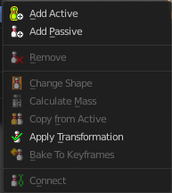
Rigid Bodies belongs to phyiscs. And can be added and modified in the physics tab in the Properties editor. This menu items here is just a quick way to add and modify the most basic things from within the 3D view.
The greyed out menu items becomes active when a rigid body is at the object.

Add Active
Add Active adds a rigid body to the selected object. The type of this rigid body is active. This is useful for any
actively moving object. Characters, bullets, etc.

Add Passive
Add Active adds a rigid body to the selected object. The type of this rigid body is passive. This is useful for any
static object, like ground for example.

Last Operator Add Rigid bodies
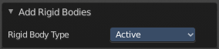
The rigid body type is a drop-down box where you can choose if the type of the rigid body is active or passive.

Remove
Remove simply removes the rigid body from the current object.

Change shape
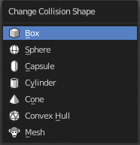
Change Shape opens a pop-up menu where you can change the shape of your rigid body.

Last Operator Change Collision shape
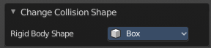
Rigid Body Shape is a pop-up menu where you can change the shape of your rigid body again.

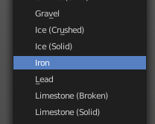
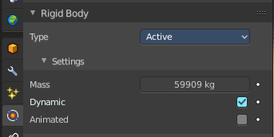
Calculate Mass
Calculate Mass does NOT calculate the mass. But gives you a long pop-up menu list where you can choose between different predefined mass set-ups. The corresponding value will then be set in the physics settings in the Rigid Body settings.

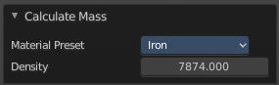
Last Operator Calculate Mass

Material Preset
Material Preset is a pop-up menu where you can choose the type of preset again.

Density
Here you can set a custom density for the material preset.

Quick Effects
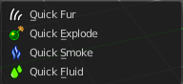
The quick effects menu contains some predefined basic Particle effects. They can be tweaked further in the Properties editor then.
You need to have a mesh object selected.

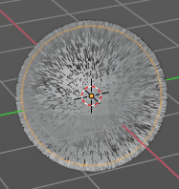
Quick Fur
Adds a particle system with Fur settings.

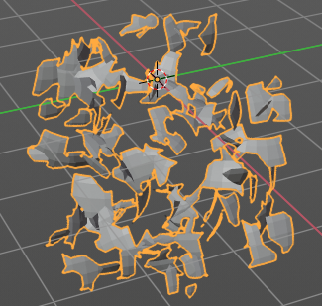
Quick Explode
Adds a particle system that lets the selected object explode into pieces.
Hit play to play the animation.

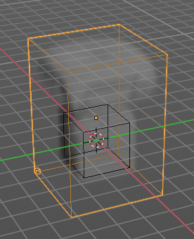
Quick Smoke
Adds a particle system with a simple smoke.

Hit play to play the animation.

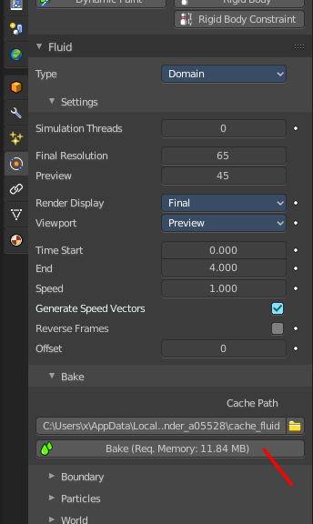
Quick Fluid
Adds a particle system with Fluid settings.
This feature does not completely work out of the box. You need to bake the animation first. This can be done in the Properties Editor, Particles Tab, Fluid Panel in the Bake subpanel.

Subdivide

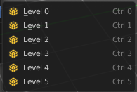
Subdivide is a menu where you can quickly set the subdivision level of the selection. What it does is to add a SDS modifier in the Properties Editor if required. And set the SDS level to the needed value. Crtrl 0 sets SDS to level 0. Ctrl 1 sets SDS level to 1 , and so on.

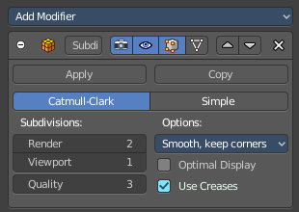
SDS happens at Object mode level. Even when you apply it in the Edit Mode! And it happens at the whole object.

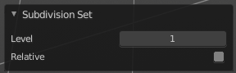
Last Operator Subdivision Set

Level
Here you can adjust the SDS level.

Relative
Applies the Subsurf Level as an offset relative to the current level.

Convert to

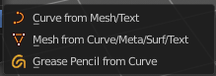
Convert to is a menu to convert curves object types to mesh objects or grease pencil strokes, and mesh object types to curves.

Curve from Mesh/Text
Converts a selected Mesh or Text Object to a Curve Object.

Mesh from Curve/Meta/Surf/Text
Converts a selected Curve, Metaball, Surface or Text Object to a Mesh Object.

Grease Pencil from Curve
Converts a selected curve to a grease pencil stroke.

Last Operator Convert to

Target
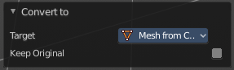
Target is a drop-down box where you can again choose between the convert methods.

Keep Original
With this option ticked the original object gets kept. And a new object gets created.

Show/Hide
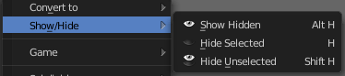
Show/Hide is a menu. Here you can show or hide objects in the viewport.

Show Hidden
Makes all geometry visible again.

Hide Selected
Hides the selected geometry.

Hide Unselected
Hides the not selected geometry. The selected geometry stays visible.

Object specific menu items

Some object types have some extra menu entries in the object menu. Those operators can usually be found at the end of the menu when you have such an object selected.

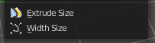
Curve and Text
Text is a special kind of a curve type. So this menu items also shows with text objects.

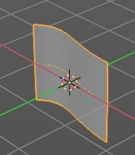
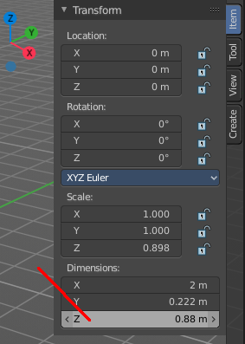
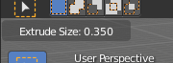
Extrude Size
Extrudes a surface out of a curve or text object.

In the header you can see the height of the extrusion. In the Transform panel in the sidebar you can adjust this height also afterwards. The Z value.

Width Size
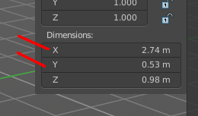
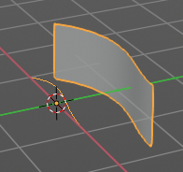
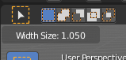
Width size is just of interest when you have a extruded surface at the curve. It scales the surface size in x and z direction.

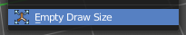
Empty, Image and Force Fields
Reference and Background Image is nothing else than a empty of type Image. So this menu entry also shows for the image types. Same counts for Force Fields. They are empties of a special kind.

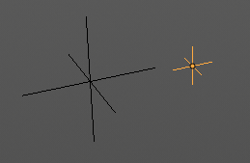
Empty Draw Size
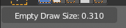
Scale the size of the empty in the viewport.
Note, this value does not show elsewhere. And there is no way to reset it to the default size except to scale it again with Empty Draw Size. The value in the header will help you.

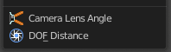
Camera

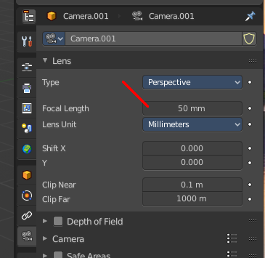
Camera Lens Angle
Changes the focal length of the camera. You can adjust it afterwards in the properties editor.
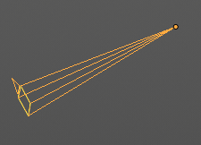

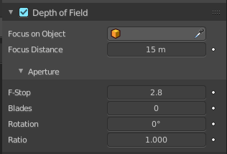
DOF Distance
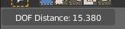
Changes the focus distance for depth of field. You can adjust it afterwards in the properties editor. The values in the depth of field are not as exact as the dof distance values though.

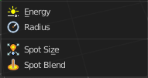
Light

Energy
Light energy adjusts the power of the light.

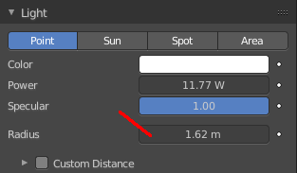
Radius
Radius adjusts the radius of the light.

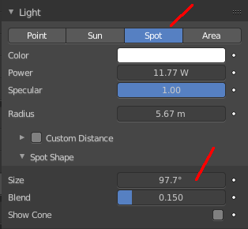
Spot Size
Spotlight only.
Spot size adjusts the angle of the spotlight beam. Note that the value in the header is in radians, while the value in the panel is in degrees.

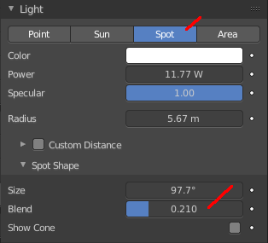
Spot Blend
Spotlight only.
Spot blend adjusts softness of the spotlight edge.

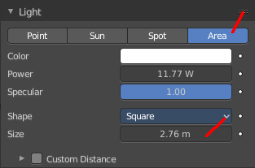
Size X
Area light only.
Size X scales the size of the area light.

